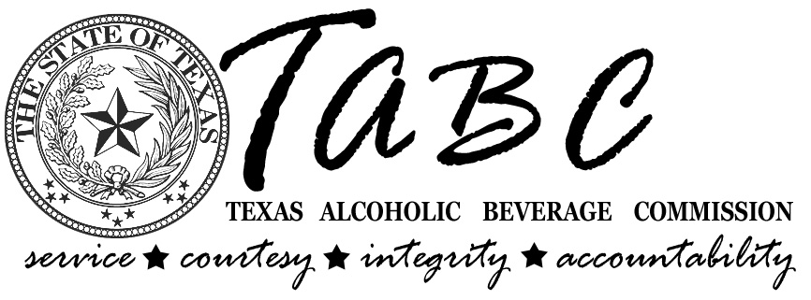
 | José Cuevas, Jr.  Presiding Officer-Midland | Steven M. Weinberg, MD, JD  Member-Colleyville | Melinda S. Fredricks  Member-Conroe | Alan Steen  Administrator

October 19, 2009

Ashley Tenney
School of Social Work
Texas State University
San Marcos, Texas

Dear Ms. Tenney:

This letter is to thank you and your team for your dedication to public safety efforts. On Oct. 2, 2009, TABC received the list that you and your team compiled outlining retail establishments in Hays, Travis, Williamson, and Dallas Counties that were out of compliance with the Fetal Alcohol Spectrum Disorder signage requirements and the condition of the signs.

Your list was forwarded to the Dallas Regional Office and the Austin Regional Office. Auditors were assigned to visit the retail establishments that were out of compliance. The auditors at this time are not fining the locations, but instead delivering new signs and reminding them of the requirement.

Thank you again for your efforts.

Sincerely,

Mindy M Carroll

Mindy M. Carroll
Assistant Director
Education and Tax Division

